Lab 6 Report
Andrew Kong, Aren Muniz, Kai Ong
May 22, 2026

Abstract:
This lab focused on analyzing the behavior of a second-order system using the Quanser QUBE-Servo under unity feedback control. The experiment explored important second-order system characteristics such as damping ratio, natural frequency, peak time, and percent overshoot. A Simulink model was developed to implement unity feedback position control, and a step input was applied to observe the servo response. The experimental response was then compared with the theoretical calculations obtained from the closed-loop transfer function. The results demonstrated the relationship between system parameters and transient response behavior, while also reinforcing concepts related to underdamped second-order systems and control system analysis.
1 System built
The system built in this lab was a unity feedback position control system for the Quanser QUBE-Servo. The setup consisted of the QUBE-Servo hardware connected to a Simulink controller through QUARC. The Simulink model implemented a unity feedback loop where the measured motor position was continuously compared to the desired reference position. The Simulink model included a step input, summing junction, gain block, encoder feedback, and motor voltage output. A 1 radian step input was applied at 1 second, and the response was observed over a 2.5 second simulation interval.
2 In-Lab Exercises and Results
- Given the QUBE-Servo closed-loop equation under unity feedback in Equation 6 and the model parameters above, find the natural frequency and damping ratio of the system.
$ωη=13.30$ rad/s
$ζ=0.29$
- Based on your obtained ωn and ζ, what are the expected peak time and percent overshoot?
$tp= .25s$
$P0 = 32\%$
- Build and run the QUARC controller. The scopes should look similar to Figure 4.
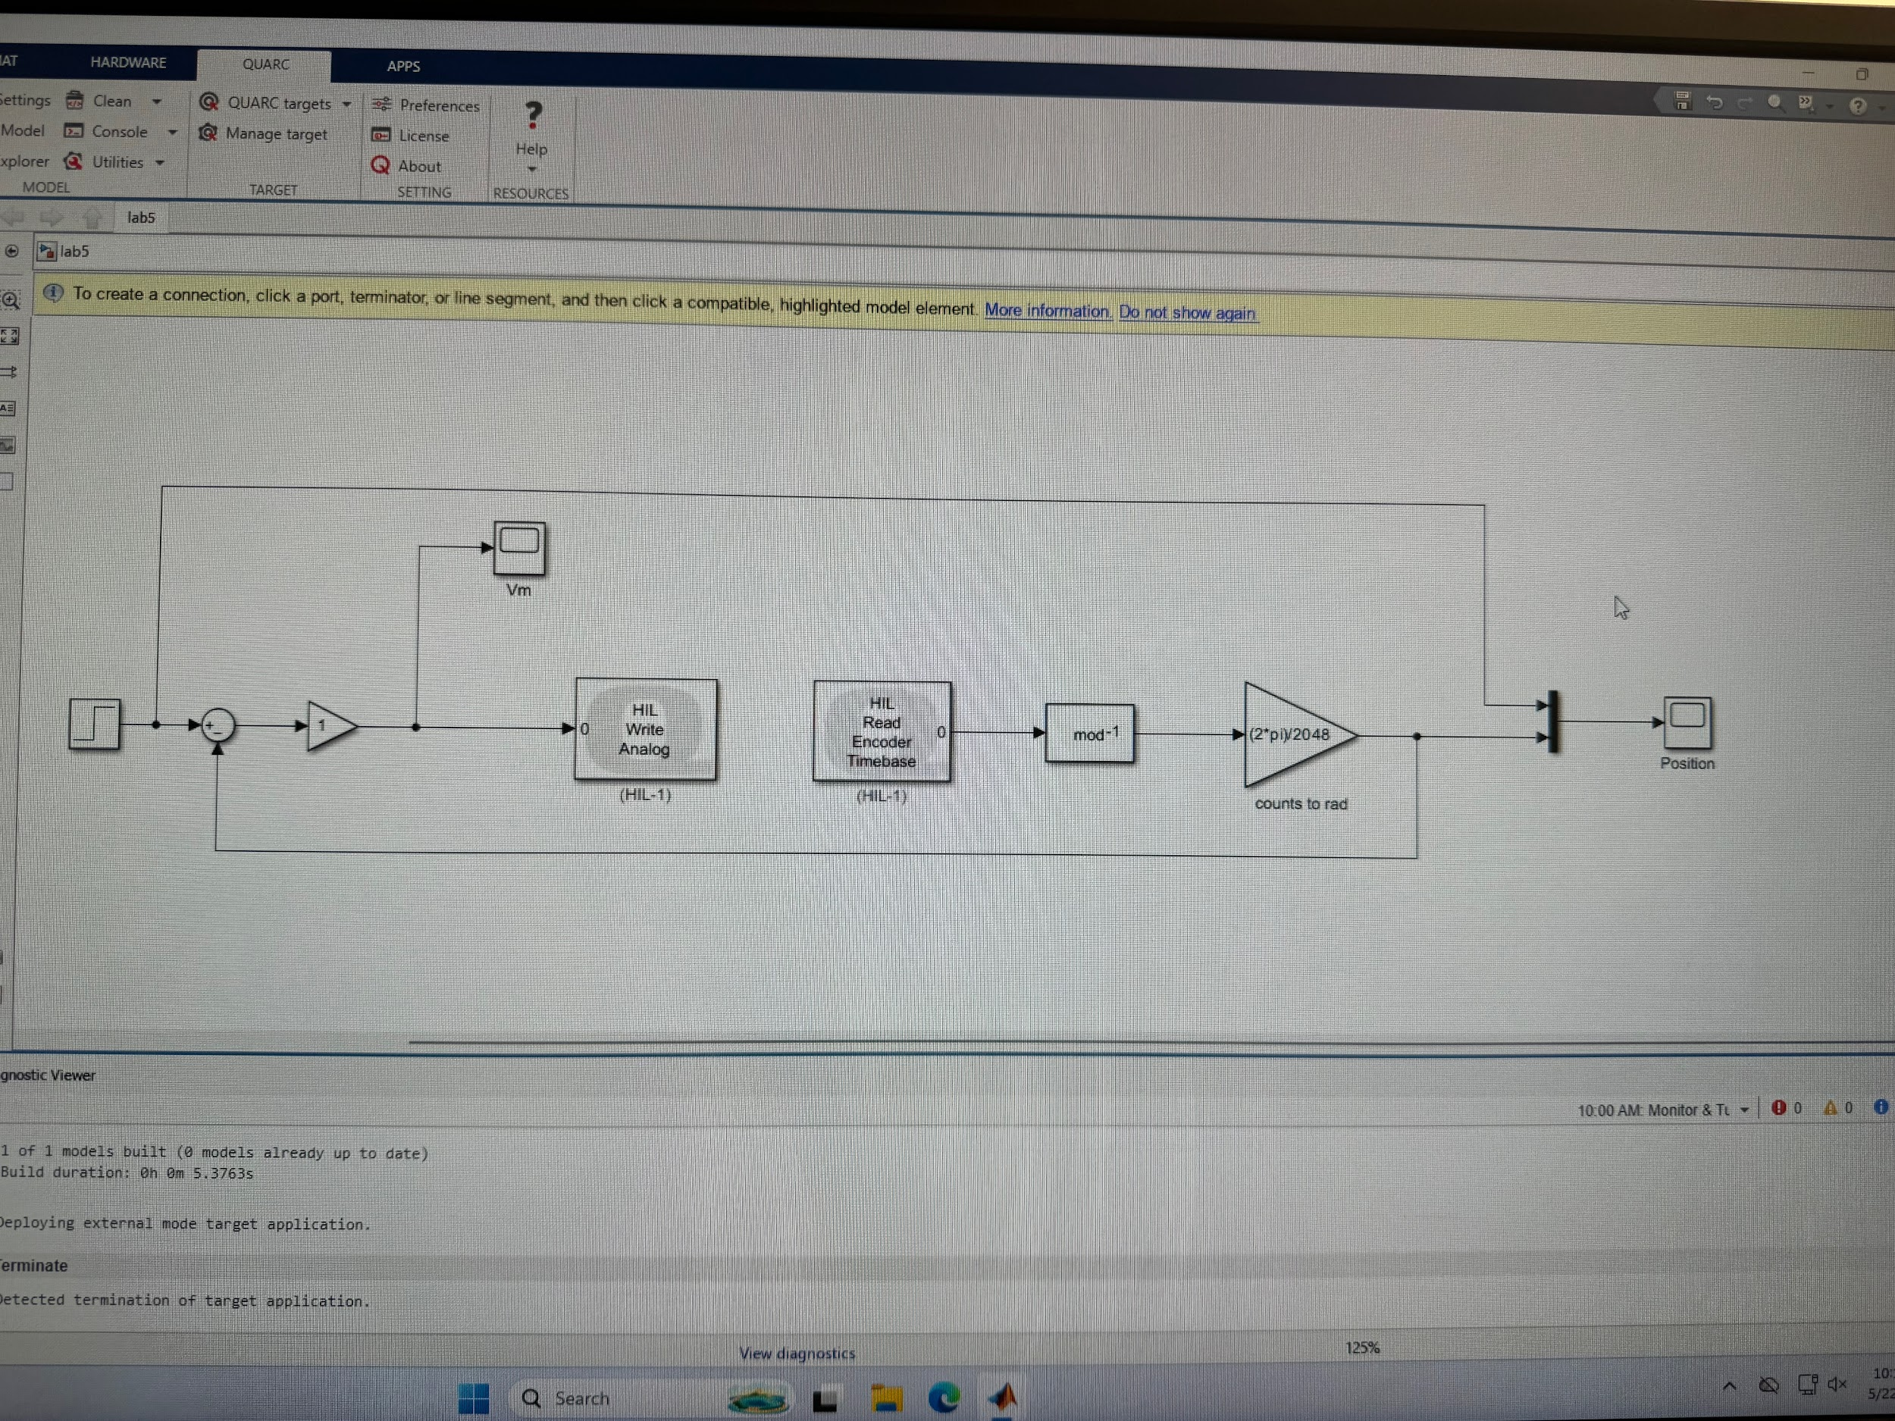
- Attach the QUBE-Servo position response — showing both the setpoint and measured positions in one scope — as well as the motor voltage.
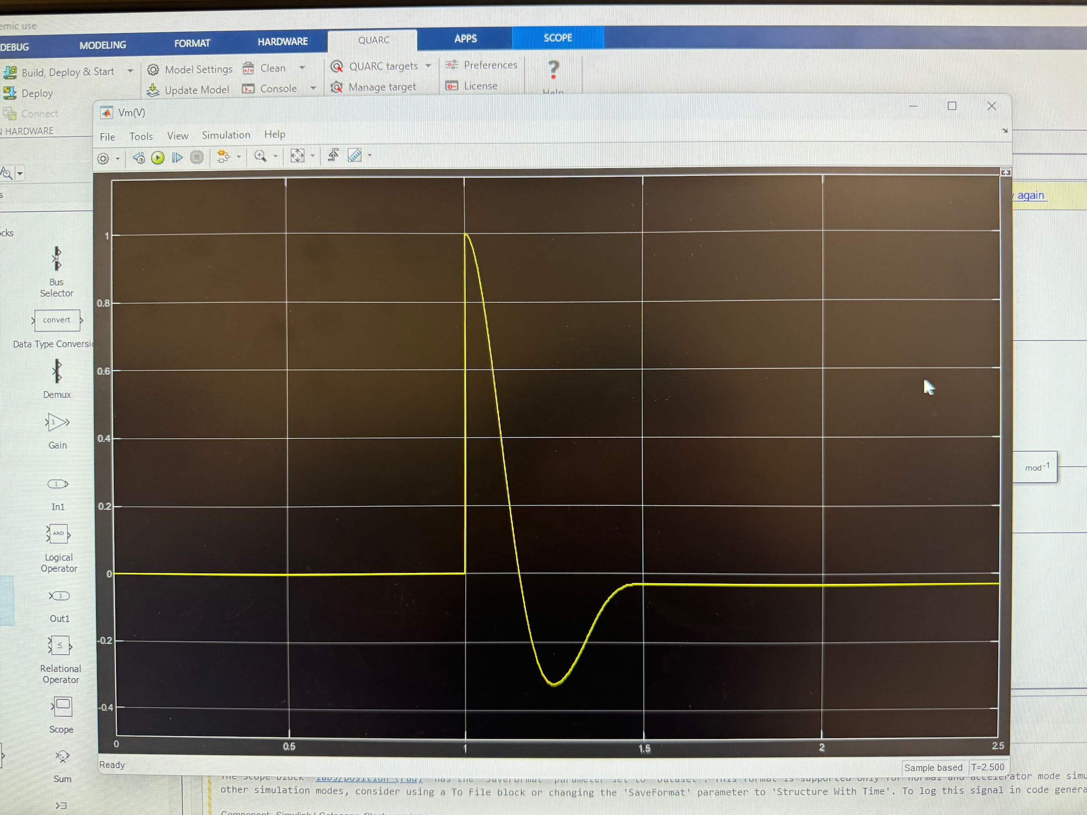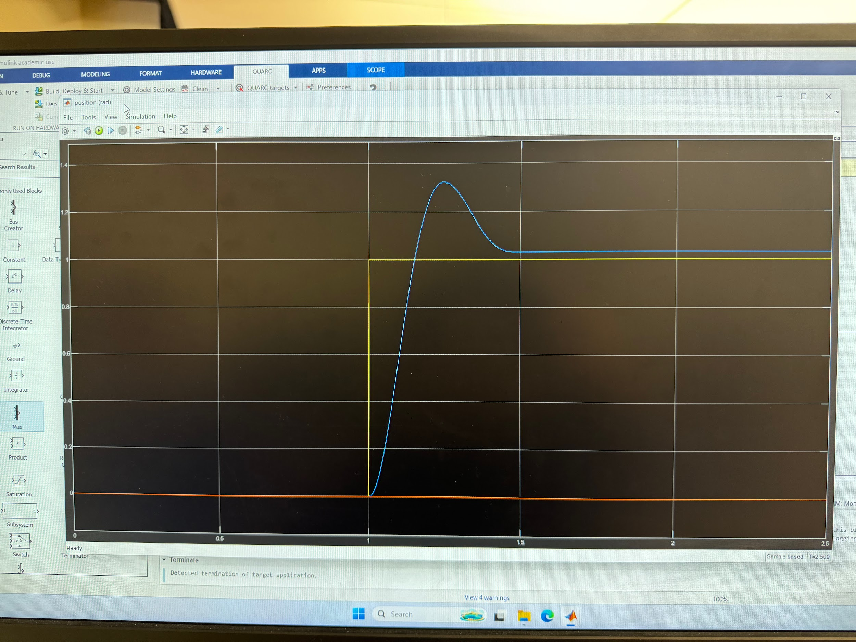
- Measure the peak time and percent overshoot from the response and compare them with your expected results.
The experimental response reached its maximum value of ymax​=1.3232 rad at tmax=1.2380s. Since the step input occurred at t0​=1.0000 s, the measured peak time was tp​=0.2380 s. The measured percent overshoot was 32.2291%. These values were close to the theoretical results, with the experimental overshoot being slightly lower than expected.
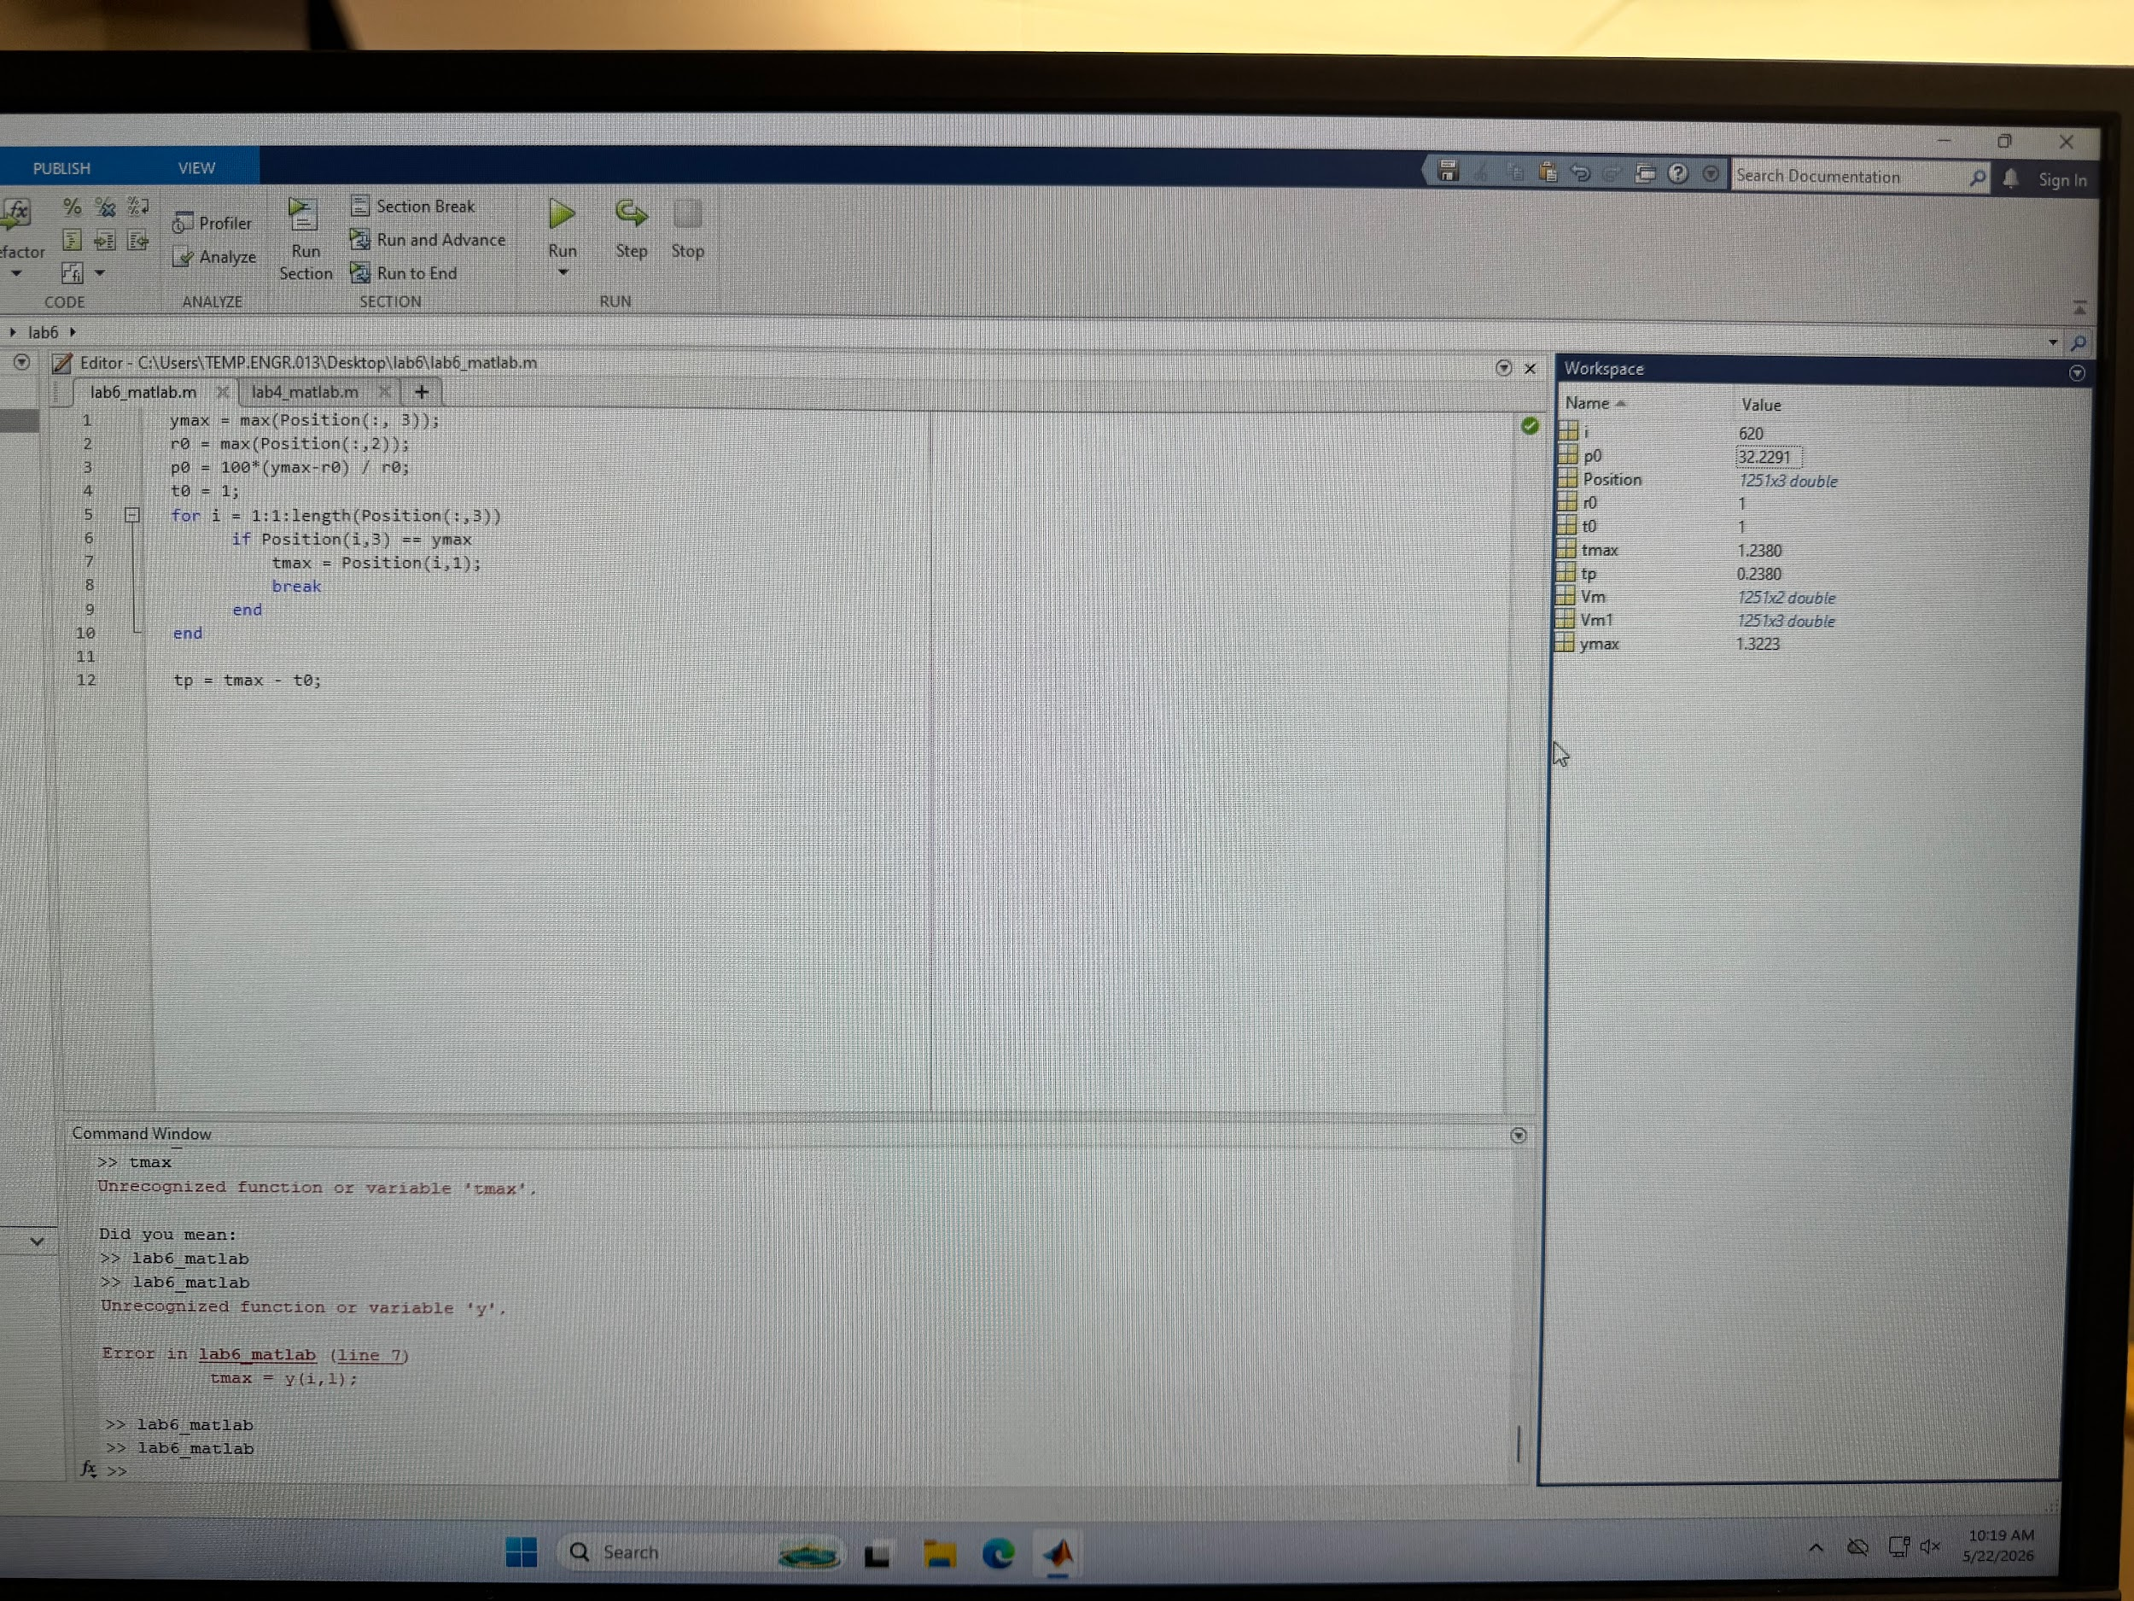

3 Analysis
Results analysis:The results confirmed the expected behavior of an underdamped second-order system. The QUBE-Servo response showed oscillations and overshoot before reaching steady state, which aligned with the calculated damping ratio and natural frequency. The measured peak time and percent overshoot were reasonably close to the theoretical values, demonstrating that the mathematical model accurately represented the system dynamics. The experiment also showed how the damping ratio affects the shape of the response while the natural frequency affects the speed of the response. A lower damping ratio resulted in larger overshoot and oscillation, while the relatively high natural frequency allowed the system to respond quickly.
Issues encountered: The only issue we had was constructing the code. We worked around it and were able to obtain the correct results
4 Conclusion
In this lab, a unity feedback position control system was implemented using the Quanser QUBE-Servo to study second-order system behavior. The experiment successfully demonstrated concepts such as damping ratio, natural frequency, percent overshoot, and peak time. Theoretical calculations were compared with experimental measurements, and the results showed strong agreement between the mathematical model and the physical system response. Overall, the lab provided practical experience with control systems, Simulink modeling, and transient response analysis of underdamped second-order systems.

